CS6503 – THEORY OF COMPUTATION

UNIT V – UNSOLVABLE PROBLEMS AND COMPUTABLE FUNCTIONS

- Recursive and Recursively Enumerable Languages
- Languages of Turing Machine:
Let M = (Q, Σ, δ, q₀, F, Г, B) be a TM and W be a string in Σ*.
Then W is accepted by M iff
$$q_{0}W⊢^{*}XpY$$
Where: p is in F, X and Y are in Г*
The language accepted by M, denoted L (M), is the set {w | w is in Σ* and w is accepted by M}.

For a Turing machine, there are two types of languages:
- Turing acceptable or Recursively Enumerable language
- Turing decidable or Recursive language

- Turing acceptable or Recursively Enumerable language:
A language is said to be recursively enumerable if there exists a TM that will accept any string W in the language or reject or loop forever any string W not in the language.
TM
M
W
Yes, if W ∈ L(M)
No or loop forever, if W ∉ L(M)

Example:
TM that accepts the language $aa^{*}$, over Σ = {a, b}

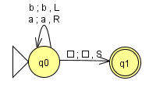

- Turing decidable or Recursive language:
A language is said to be recursive if there exists a TM that will accept any string W in the language or reject any string W not in the language.
TM
M
W
Yes, if W ∈ L(M)
No, if W ∉ L(M)

Example: TM that accepts the language $L=\{a^{n}b^{n}c^{n} n≥0\}$.

- Properties of Recursive and Recursively Enumerable languages:

The following are the properties of the Recursive and Recursively Enumerable languages.
- If L is recursive then L is recursively enumerable.
- If L is recursive then its complement, L’, is recursive.
- If L and L’ are recursively enumerable then both (L and L’) are recursive.
- If L₁ and L₂ are recursive languages then
  - L₁ ∪ L₂ is recursive (Union)
  - L₁ ∩ L₂ is recursive (Intersection)
  - L₁ ⋅ L₂ is recursive (Concatenation)
  - L₁* is recursive (Closure)
- If L₁ and L₂ are recursively enumerable languages then
  - L₁ ∪ L₂ is recursively enumerable (Union)
  - L₁ ∩ L₂ is recursively enumerable (Intersection)
  - L₁ ⋅ L₂ is recursively enumerable (Concatenation)
  - L₁* is recursively enumerable (Closure)

Theorem 1: If L is recursive then L is recursively enumerable. Or
Every recursive language is recursively enumerable language.
Proof:
- Let there is a Turing Machine M that decides the language L. i.e.,
- TM M halts and accepts a string W belongs to L
- TM M halts and rejects a string W nod belongs to L
- These conditions are satisfied for a recursively enumerable language also. The difference is that, the TM M will halt for a recursive language but may not halt (loop forever) for recursively enumerable language.
- From M, it is possible to construct a Turing machine $M^{|}$ that accepts or semi-decides L as below:
TM
M
W
Yes
No
Yes, if W ∈ L(M)
No, if W ∉ L(M)
TM $M^{|}$

Theorem 2: If L is recursive then its complement, L’, is recursive.
Proof:
- Let there is a Turing Machine M that decides the language L. i.e.,
- TM M halts and accepts a string W belongs to L
- TM M halts and rejects a string W nod belongs to L
- Construct a machine $M_{c}$ that decides L’ as below such that
$M_{c}$ Rejects W if M accepts and
$M_{c}$ Accepts W if M rejects
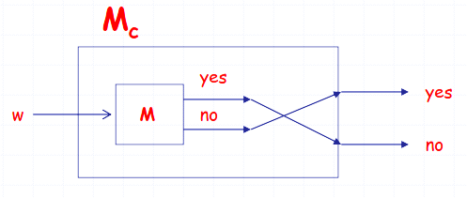

Theorem 3: If L and L’ are recursively enumerable then both (L and L’) are recursive.
Proof:
- Let $M_{1} \& M_{2}$ be the Turing Machines for the languages L and L’.
- Construct a two-tape TM $M^{'}$ to simulate M₁ and M₂ for the input ‘W’ as below
  - Simulate M₁ on tape 1.
  - Simulate M₂ on tape 2.
- If M₁ accepts W then $M^{'}$ accepts.
- If M₂ accepts W then $M^{'}$ rejects.
- From the above, it is clear that $M^{'}$ always halts for any given string.
- Therefore L (M) is recursive. Since the complement of recursive language is recursive, L‛ is recursive.
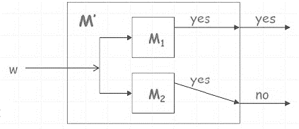

Theorem 4: If L₁ and L₂ are recursive languages then L₁ ∪ L₂ is recursive or Union of two recursive
languages is recursive.
Proof:
- Let M₁ and M₂ be the TMs for the languages L₁ and L₂. For any input, M₁ and M₂ always halts.
- Construct a two-tape TM M_{u} to simulate M₁ and M₂ for the input ‘W’ as below
  - Simulate M₁ on tape 1.
  - Simulate M₂ on tape 2.
  - If M₁ or M₂ accepts W then M_{u} accepts and halts.
  - Otherwise M_{u} rejects and halts.
- From the above, it is clear that M_{u} always halts for any given string.
- Therefore M_{u} accepts L₁ ∪ L₂. Hence it is recursive.
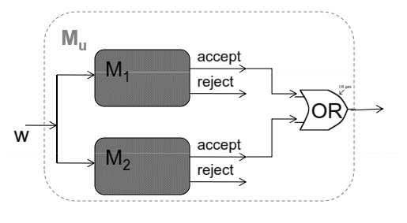
Accept
Reject

Theorem 5: If L₁ and L₂ are recursive languages then L₁ ∩ L₂ is recursive or Intersection of two recursive languages is recursive.
Proof:
- Let M₁ and M₂ be the TMs for the languages L₁ and L₂. For any input, M₁ and M₂ always halts.
- Construct a two-tape TM M_{n} to simulate M₁ and M₂ for the input ‘W’ as below
  - Simulate M₁ on tape 1.
  - Simulate M₂ on tape 2.
  - If M₁ and M₂ accepts W then M_{n} accepts and halts.
  - Otherwise M_{n} rejects and halts.
- From the above, it is clear that M_{n} always halts for any given string.
- Therefore M_{n} accepts L₁ ∩ L₂. Hence it is recursive.
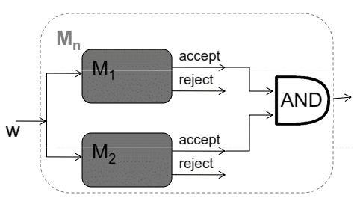
Accept
Reject
Theorem 6: If L₁ and L₂ are recursively enumerable languages then L₁ ∪ L₂ is recursively
enumerable or Union of two recursively enumerable languages is recursively enumerable.
Proof:
- Let M₁ and M₂ be the TMs for the languages L₁ and L₂. For some input, M₁ and M₂ may halts.
- Construct a two-tape TM M_{u} to simulate M₁ and M₂ for the input ‘W’ as below
  - Simulate M₁ on tape 1.
  - Simulate M₂ on tape 2.
  - If M₁ or M₂ accepts W then M_{u} accepts and halts.
  - Otherwise M_{u} rejects or loop forever.
- From the above, it is clear that M_{u} halts only for the string belongs to L₁ or L₂.
- Therefore M_{u} accepts L₁ ∪ L₂. Hence it is recursively enumerable.
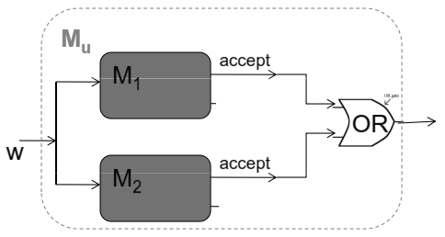
Accept

Theorem 7: If L₁ and L₂ are recursively enumerable languages then L₁ ∩ L₂ is recursively
enumerable or Intersection two recursively enumerable languages is recursively enumerable.
Proof:
- Let M₁ and M₂ be the TMs for the languages L₁ and L₂. For some input, M₁ and M₂ may halts.
- Construct a two-tape TM M_{n} to simulate M₁ and M₂ for the input ‘W’ as below
  - Simulate M₁ on tape 1.
  - Simulate M₂ on tape 2.
  - If M₁ and M₂ accepts W then M_{n} accepts and halts.
  - Otherwise M_{n} rejects or loop forever.
- From the above, it is clear that M_{n} halts only for the string belongs to both L₁ and L₂.
- Therefore M_{n} accepts L₁ ∩ L₂. Hence it is recursively enumerable.

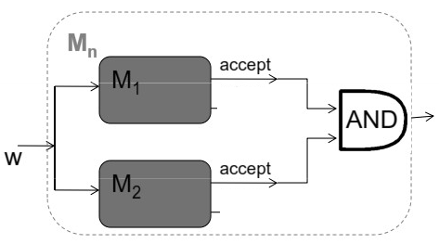
Accept
- Universal Turing Machine (UTM)
- Definition:
- Universal Turing Machines are general purpose Turing machines capable of simulating the action of any other Turing Machine.
- It is similar to stored program concept given by Von Neumann in 1943.
- Universal Turing Machine can be programmed like general purpose computer.

- Description:
- A Universal Turing Machine (T_{u}) takes the following two arguments in the encoded format
  - The description of the computation (description of TM M need to be simulate)
  - The description of the input string
Universal Turing Machine T_{u}
<TM M, w>
Accept, if M accept W
Reject, if M does not accept W

- For a given TM M and its input string W, build a Universal Turing Machine T_{u}, such that the machine T_{u} works as follows:
  - Simulate M on W by T_{u}
  - $T_{u} \left(M,w\right)=\left\{\begin{aligned}accept if M accepts w \\ reject if M does not accept w\end{aligned}\right.$

- Encoding Procedure:
Let M = (Q, Σ, δ, q₁, q_{n}, Г, B) be a TM and w is the string ∈ Σ*. Here,
  - Input alphabet: $=\{a_{1},a_{2}, a_{3}, …. , a_{n} \}$
  - Tape alphabet: $Г=\left\{{B, a}_{1},a_{2}, a_{3}, …. , a_{n} \right\}$
  - States $Q=\{q_{1},q_{2}, q_{3}, …. , q_{n} \}$
  - $q_{1} is the initial state$
  - $q_{n} is the final state$

The above elements are encoded using a string 0’s as below:
Element (x) | Encoded Element e(x)
Tape alphabet:  B  $$a_{i}$$ | 0  $$0^{i+1}$$
States:  $$q_{i}$$  $${Initial state q}_{1}$$  $${Initial state q}_{n}$$ | $$0^{i}$$  $$0^{1}$$  $$0^{n}$$
Direction (D) of Tape head  S  L  R | 0  00  000

Let δ(p, a) = (q, X, D) be a transition function of a Turing Machine M and it is encoded as below:
$$e\left(δ\right)=e\left(p\right) 1 e\left(a\right) 1 e\left(q\right) 1 e\left(X\right) 1 e(D)$$

Let TM M with the k number of distinct moves $δ_{1}, δ_{2}, δ_{3}, …. , δ_{k}$, are encoded as below:
$$e\left(M\right)=e\left(δ_{1}\right) 11 e\left(δ_{2}\right) 11 e\left(δ_{3}\right) 11……, e\left(δ_{n}\right)$$

In general, the encoded value of TM M with the input string W is presented to the Universal Turing Machine as below:
$$e\left(M\right) 111 e\left(W\right)$$

- Simulation of UTM:
The working of a Universal Turing Machine $T_{u}$ is simulated using a three-tape Turing Machine. The three-tape Turing machine is constructed as below:
    - First tape contains the encoded value of the TM M.
    - Initially, the second tape contains the encoded value of the input string and it is used as working tape of the machine M.
    - Initially, third tape contains encoded value of the initial state and subsequently it holds the encoded value of the current state.

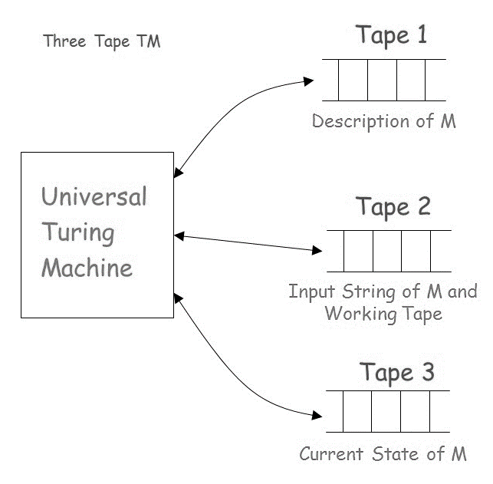

- Universal Language (Lu):
The language accepted by the Universal Turing Machine $T_{u}$ is called Universal Language. Formally, $L_{u}$ is defined as,
$$L\left(T_{u}\right)=\left\{e\left(w\right)\right| M accepts w; w{}^{*};\left(q_{1},w\right) ⊢_{}^{*} \left(q_{a},XaY\right)\}$$

Theorem 8: $L_{u}$ is recursively enumerable.
Proof:
- Let there is a multi-tape Turing Machine M_{u} simulating the another TM M with the input W, such that
- TM M halts and accepts a string W belongs to L
- TM M halts and rejects a string W nod belongs to L
- For a given TM M and its input string W, build a Universal Turing Machine M_{u}, such that the machine M_{u} works as follows:
  - Simulate M on W by M_{u}
  - $M_{u} \left(M,w\right)=\left\{\begin{aligned}accept if M accepts w \\ reject if M does not accept w\end{aligned}\right.$
TM
M
W
Yes
No
Yes, if W ∈ L(M)
Loop forever
if W ∉ L(M)
TM $M_{u}$

- From the above, it is clear that M_{u} halts only for some strings belongs to L(M).
- Therefore, L_{u} contains the strings that are belongs to L. Hence it is recursively enumerable.

- Undecidable Problems:

- Solvable or Decidable problem:
A problem that can be solved for all cases by a Turing Machine or algorithm is called a solvable or decidable problem.

- Unsolvable or Undecidable problem:
A problem that cannot be solved for all cases by a Turing Machine or algorithm is called Unsolvable or Undecidable problem.

- Examples for Undecidable problem:
The following is the list of undecidable problems:
  - Halting Problem
  - Hilbert’s Problem
  - Rice’s theorem
  - Post Correspondence Problem

- Halting Problem:
Definition:
Halting problem is a kind of membership problem for the recursively enumerable language. Formally, the Halting problem is defined as below:
For a given TM M and a string W, it asks whether M halts (by accepting or rejecting) on input W $H=\left\{e\left(M\right) e\left(W\right)\right| H halts on input W\}$
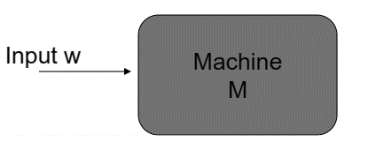
Whether M halts on W?

Theorem 9: Halting Problem is Undecidable.
Proof:
- Given: L be the language of a Turing Machine M and input W is represented as
$$L\left(M\right)=\{<M,W>and M halts on input W\}$$

- Assumption:
If H is a decider for the language L(M),
Then H accepts and halts W if M accepts
Else H rejects and halts W if M rejects
$$H \left(M,w\right)=\left\{\begin{aligned}accept& and halts if M accepts w \\ reject and halts if M does not accept w\end{aligned}\right.$$
- Construct a TM D with H itself as input (H is treated as subroutine) to produce the complement of H as output and the behavior of D is as follows:
$$D \left(H,w\right)=\left\{\begin{aligned}accept& and halts if H rejects w \\ reject and halts if H accepts w\end{aligned}\right.$$
TM H (M, W)
– Output is same as M
TM D (H, W)
– Output is complement of H
TM M and the input W

- Conclusion:
From the above, it is noted that the TM D rejects the input W which belongs to its language. Therefore a contraction is occurred and the assumption made is wrong. Hence, there exists no Turing Machine to determine whether a TM halts on the input. Hence, halting problem is undecidable.

- Post Correspondence Problem (PCP):

Definition:
The problem was formulated by Emil Post in 1940. An instant of PCP consists of a set of pairs of non-null strings $\left(x_{1},y_{1}\right), \left(x_{2},y_{2}\right), \left(x_{3},y_{3}\right),……. , \left(x_{n},y_{n}\right)$over an alphabet Σ. The problem is to determine whether there is a sequence of one or more integers $i_{1}, i_{2}, i_{3}, …, i_{k}$ such that
$x_{i1 }x_{i2 }x_{i3 }…. …….. x_{ik }$= $y_{i1 }y_{i2 }y_{i3 }…. …….. y_{ik }$
Example:
- Consider the instance given below for the PCP
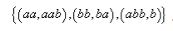

The Solution is: 1, 2, 1, 3 i.e.,
aabbaaabb = aabbaaabb

- Consider the instance given below for the PCP
{(aab, aa), (a, baa)}
For this instance, No solution is exists.

- Modified PCP (MPCP)
The Modified PCP is a special type of PCP in which the solution should start with the first pair of the instance i.e. $\left(x_{1},y_{1}\right)$

- Theorem 10: PCP is Undecidable:
Proof:
- This theorem can be proved by means of Problem Reduction technique. It can be done in two levels:
  - First, instance of the given PCP is reducible to Modified PCP
  - Then the Modified PCP is reduced to Halting Problem
  - As, it is claimed already that, the Halting Problem is undecidable. Obviously Modified PCP is also undecidable.

Instance of Modified PCP
Instance of Halting Problem
Instance of PCP

- From the above, MPCP is undecidable and therefore PCP is undecidable.

- Complexity Classes:
- Tractable Problem:
The problem that can be solved for all instances by a TM or Algorithm with in a polynomial time is called tractable problem.

- Intractable Problem:
The problem that cannot be solved for all instances by a TM or Algorithm with in a polynomial time is called intractable problem.

- Class P: Class P is the set of all problems that can be solved in polynomial time by a deterministic Turing Machine or Algorithm.
Example: Searching, Sorting, Minimum Spanning Tree, Matrix manipulations

- Class NP: Class NP is the set of all problems that can be solved in polynomial time by a Non-deterministic Turing Machine or Algorithm
Example: Hamiltonian circuit problem, Boolean problem, Clique problem

Solving any NP P problem involves two stages:
Stage 1: Guess the solution S of the problem P. (Non-Deterministic Stage)
Stage 2: Verify the whether S is the solution to the problem P by a polynomial time
Verification algorithm. (Deterministic Stage)

- Polynomial time reduction:
A problem P can be reduced to another problem Q if any instance of P can be rephrased to an instance of Q, the solution to which provides a solution to the instance of P
Example: LCM (m, n) = m * n / GCD (m, n),
LCM (m,n) problem is reduced to GCD (m, n) problem

- NP Complete:
A problem P is said to be NP-Complete, if it satisfies the following conditions:
  - P is in NP Class.
  - Every other problem Q in NP is polynomial time reducible to P.

Examples:
- Boolean Satisfiability problem
- Knapsack problem
- Hamiltonian path problem
- Travelling salesman problem
- Subset sum problem
- Clique problem
- Vertex cover problem
- Independent set problem
- Graph coloring problem
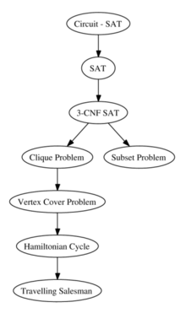

- Relationships among complexity classes:

