CS6503 – THEORY OF COMPUTATION

UNIT IV – TURING MACHINES
- Important Definitions:
- Definition of TM
TM is the most powerful abstract computational machine introduced by Alan Turing in 1936. Formally, a TM is a seven-tuple defined by
M = (Q,Σ,δ, q₀, F, Г, B)
Where Q: finite set of states
Σ: finite set of input alphabets
Г: finite set of tape alphabets including B
q₀: initial state of the TM, q₀ ∈ Q
F: finite set of final states, F ⊆ Q
B: tape blank symbol
δ: transition function defined as Q x Г → Q x Г x {L, R,S}

Note: TM permits separate final states (q_{a} or q_{r}) accepting and rejecting the strings

Important observations:
- No ɛ-transitions are allowed in TM
- No outgoing transitions are allowed from the final state
- For any string W, the TM can have the following possibilities:
- The TM can halt at final state for accepting
- The TM can halt at final state for rejecting
- The TM never halt and creates infinite loop

- Compare FA, PDA and TM
S. No. | Finite Automata (FA) | Push Down Automata (PDA) | Turing Machine (TM)
1 | Five tuple automata | Seven tuple automata | Seven tuple automata
2 | No auxiliary memory | Limited auxiliary memory in the form of Stack | Unlimited memory in the form of tape
3 | Deterministic by default | Non-deterministic by default | Deterministic by default
4 | Less power full than PDA in terms of language acceptance | More power full than NFA in terms of language acceptance | More power full than FA & PDA in terms of language acceptance
5 | Accepting only regular languages | Accepting both regular and context free languages | Accepting all class of languages
6 | Tape head can perform only read operation | Tape head can perform only read operation | Tape head can perform both read and write operation
7 | Tape head can travel only in forward (right) direction | Tape head can travel only in forward (right) direction | Tape head can travel in both right & left direction
8 | One way infinite tape | One way infinite tape | Two way infinite tape
9 | FA stop its work only when the input string in the tape has been processed completely | PDA stop its work only when the input string in the tape has been processed completely | TM stop its work immediately when it enters into the final state irrespective of the input string in the tape
10 | Ex: $L=\left\{a^{n} \right| n≥0\}$ | Ex: $L=\{a^{n}b^{n} | n≥0\}$ | Ex: $L=\{a^{n}b^{n}c^{n} | n≥0\}$
- Transition of a TM
The transition of a Turing Machine is represented as
δ(p, a) = (q, X, D)
Where, p is the current state, p∈Q; q is the next state, q∈Q
a is the current tape symbol, a∈Г; X is the symbol to be write onto the tape, X∈Г;
D is the direction of tape head movement; D∈{L,R,S}

- Instantaneous Description (ID) of TM or configuration of TM
ID of a TM is a triple define as below used to describe the way of accepting the given string W by a TM.
(q, XaY)
where q is the current state,
XaY is the string made from the tape symbols (Г*),
a is the current symbol pointed by the tape head

Formally, let M = (Q, Σ, δ, q₀, F, Г, B) be a TM, then the ID of TM is:
(p, XaY) ⊢ (q, ZbW)
Initial ID: (q₀, W)
Final ID: (q_{f}, XY)

- Language Accepted by TM
Formally, Let M = (Q, Σ, δ, q₀, F, Г, B) be a TM, w is the string ∈ Σ*. The language accepted by TM is defined as
$L(M)=\left\{w\right|w*,\left(q_{0},w\right) ⊢_{}^{*} \left(q_{f},XaY\right)\}$
Where $q_{f}$ ∈ F; XaY∈Г*;a is the current tape symbol

- Programming Techniques and Variants of TM
The basic Turing Machine may be extended to the following features in order to increase the power of the Turing Machine.
- Turing Machine with Storage in the finite control
- Turing Machine with Subroutines
- Multitrack Turing Machine
- Multi Head Turing Machine
- Multiple Tape Turing Machine
- Non-Deterministic Turing Machine
- Universal Turing Machine

- Chomsky Hierarchy of Languages
Noam Chomsky, the founder of formal language provided a classification for the formal languages in 1959 as given below:
- Type 0 Language (Unrestricted)
- Type 1 Language (Context Sensitive)
- Type 2 Language (Context Free)
- Type 3 Language (Regular)

Where Type 0 is superset of type 1, type 1 is superset of type 2, type 2 is superset of type 3 languages.

S. No. | Language Types | Grammar | Definition | Recognizer
1 | Type 3 -  Regular Language | Regular Grammar or Regular Expression | A→a, A→ε, A → a B where A, B ∈ N &  a ∈ T | Finite Automata (FA)
2 | Type 2 –  Context Free | Context Free  Grammar (CFG) | A → β  where A ∈ N,  β ∈ (N, T)* | Push Down Automata (PDA)
3 | Type 1 –  Context Sensitive | Context Sensitive  Grammar (CSG) | α → β  where α, β ∈ (N, T)*  α ≠ ε & |α| ≤ |β| | Linear Bounded Automata (LBA)
4 | Type 0 –  Recursive | Unrestricted  Grammar | α → β  where α, β ∈ (N, T)*  α ≠ ε | Turing Machine (TM)
5 | Type 0 –  Recursively Enumerable Languages | Unrestricted  Grammar | α → β  where α, β ∈ (N, T)*  α ≠ ε | Turing Machine (TM)

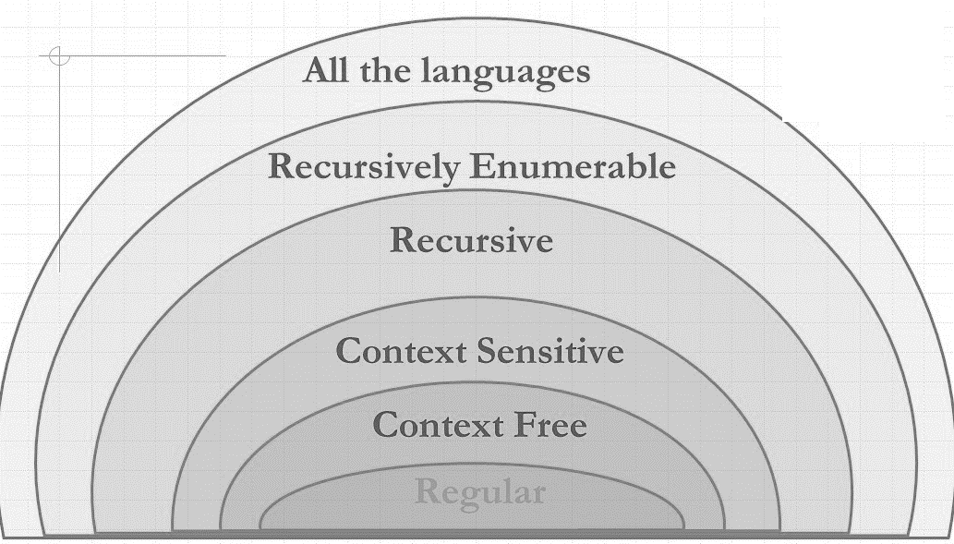
The Chomsky Hierarchy of Formal Languages

- Models of TM or Roles of TM
TM is designed to perform the following roles:
- TM as a Language Recognizer
- TM as a Computer of Functions (Transducer)
Language Recognizer:
Similar to FA and PDA, Turing Machine can also recognize languages. TM process the strings of the language starting from the leftmost symbol goes through a sequence of moves until the last symbol of the string and enters into some state. If the state is final, then the string is accepted otherwise rejected.
Turing Machine M
Yes, if W ∈ L(M)
No, if W ∉ L(M)
W

Examples:
- $L=\{0^{n}1^{n} n≥1\}$
- $L=\{0^{n}1^{n}2^{n} n≥1\}$
- $L=\left\{wcw \right| w∈{(a,b)}^{*}\}$

Transducer (Computer of Integer Functions):
The most powerful role of the TM is to compute any kind of functions known as partial function which will transform the given input into some input. Hence, TM is saying that an abstract model of digital computer.
Turing Machine M
$$Y=f(X)$$
X

Let M be a Turing machine and X to be the input string on its tape. The TM halts when the string on its tape is Y, i.e., the output Y is computed as the function over X.

In order to design TM as a computing device, the following assumptions are considered:
- The arguments to the functions are only the non-negative integer.
- The arguments to the functions are represented using Unary notation. i.e., any non-negative integer ‘K’ can be encode as the ‘K’ number of successive 1’s. ($1^{K}$).
- If a function $f(x1, x2, …, xn)$ has to be computed
  - The arguments $x1, x2, ... , xn$is represented by the corresponding number of successive 1’s
  - The arguments are separated by any other special symbol.
  - Initial tape content is
$$……. B B B B 1^{x1}1^{x2}…… 1^{xn} B B B B B B………….$$
  - Before the process starts, the head is positioned at the left most symbol of the input.
- The TM is said to have computed $Y= f(x1, x2, …, xn)$, when it halts and the tape consists of the result.
Examples:
- $f\left(x,y\right)=x+y$
- $f\left(x,y\right)=x*y$
- $f\left(x\right)=x+1$
- Important Problems on TM (Language Recognizer):
- TM for the language $L=\{0^{n}1^{n} n≥1\}$
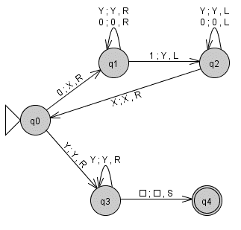
Description:
Step 1: Repeat the following until all 0’s and 1’s are marked
- Mark ‘0’ by X and move forward until first ‘1’ appears
- Mark first ‘1’ by Y and move backward until first ‘X’ appears.
- Move one cell right.
Step 2: If the tape is having only X’s and Y’s then accept the string. Otherwise reject.

- TM for the language $L=\{0^{n}1^{n}2^{n} n≥1\}$
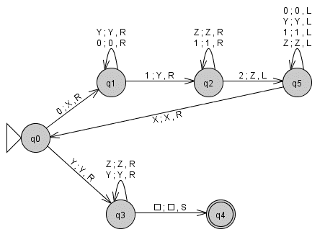
Description:
Step 1: Repeat the following until all 0’s, 1’s and 2’s are marked
- Mark ‘0’ by X and move forward until first ‘1’ appears
- Mark first ‘1’ by Y and move forward until first ‘2’ appears.
- Mark first ‘2’ by Z and move backward until first ‘X’ appears.
- Move one cell right.
Step 2: If the tape is having only X’s and Y’s then accept the string. Otherwise reject.

- TM for the language $L=\{a^{i}b^{j} i<j\}$
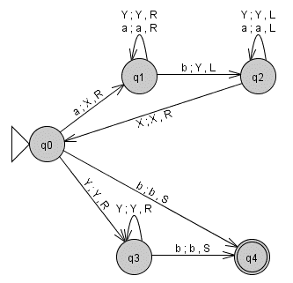
Description:
Step 1: Repeat the following until all a’s and b’s are marked
- Mark ‘a’ by X and move forward until first ‘b’ appears
- Mark first ‘b’ by Y and move backward until first ‘X’ appears.
- Move one cell right.
Step 2: Move forward, if the tape is having any b’s then accept the string. Otherwise reject.

- TM for the language of Palindrome strings over (a ,b)*
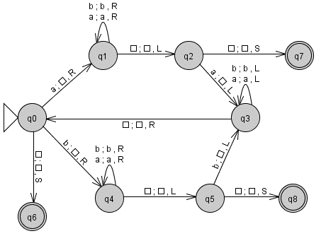
Description:
Step 1: Repeat the following until all a’s and b’s are marked as blank
- Mark first ‘a’ by B, move forward, mark last ‘a’ by B (or)
Mark first ‘b’ by B, move forward, mark last ‘a’ by B
- Move backward until first ‘B’ appears.
- Move one cell right.
Step 2: If the tape is having only blank B’s then accept the string. Otherwise reject.
- TM for the language $L=\{x∈{\left(a,b\right)}^{*}|n_{a}\left(x\right)=n_{b}(x)\}$ or No. of a’s equal to No. of b’s.
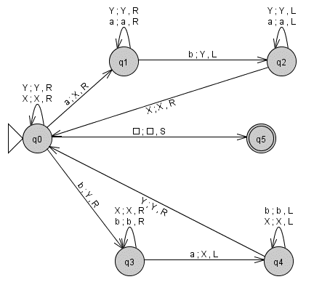
Description:
Step 1: Repeat the following until all a’s and b’s are marked
- Mark first ‘a’ by X, move forward, mark first ‘b’ by Y (or)
Mark first ‘b’ by Y, move forward, mark first ‘a’ by X
- Move backward until first ‘a’ or ‘b’ appears.
Step 2: If the tape is having only X’s and Y’s then accept the string. Otherwise reject.

- TM for the language of strings containing balanced parenthesis
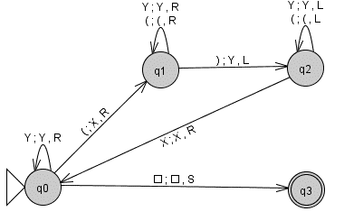
Description:
Step 1: Repeat the following until all ‘(’s and ‘)’s are marked
- Mark first ‘(’ by X, move forward until the first ‘)’ appears
- Mark first ‘)’ by Y, move backward until the first ‘X’ appears
- Move forward until first ‘(’ appears
Step 2: If the tape is having only X’s and Y’s then accept the string. Otherwise reject.
- TM for the language $L=\left\{wcw \right| w∈{(a,b)}^{*}\}$
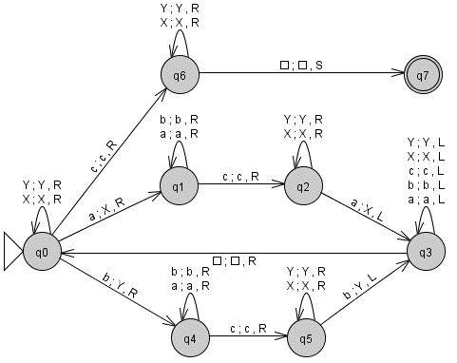

Description:
Step 1: Repeat the following until all a’s and b’s are marked
- Mark first ‘a’ by X, move forward until c appears & mark first ‘a’ by X (or)
Mark first ‘b’ by Y, move forward until c appears & mark first ‘b’ by Y
- Move backward until first blank ‘B’ appears
- Move forward until first ‘a’ or ‘b’ appears
Step 2: If the tape is having only ‘c’ followed by X or Y then accept the string. Otherwise reject.

- TM for the language $L=\{0^{2n}1^{n} n≥1\}$
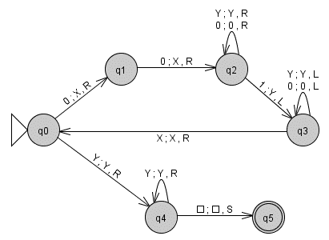
Description:
Step 1: Repeat the following until all 0’s and 1’s are marked
- Mark two ‘0’s by X and move forward until first ‘1’ appears
- Mark first ‘1’ by Y and move backward until first ‘X’ appears.
- Move one cell right.
Step 2: If the tape is having only X’s and Y’s then accept the string. Otherwise reject.

- Important Problems on TM (Computing Functions):
- TM to compute $Add\left(x,y\right)=x+y$:
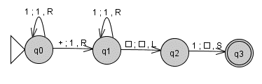
Description:
Step 1: Move forward until the ‘+’ symbol appears and replace by 1.
Step 2: Move forward until the last ‘1’ appears and replace by blank ‘B’. Stop.

- TM to perform Proper subtraction or Monus operation:
$$Sub\left(x,y\right)=\left\{\begin{aligned}x-y if x≥y \\ 0 otherwise\end{aligned}\right.$$

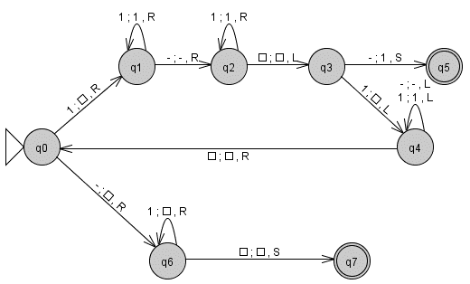
Description:
Step 1: Repeat the following until all 1’s are marked with blank ‘B’
- Mark first ‘1’ by B and move forward
- If the tape is having blank ‘B’ next to ‘-‘ immediately, mark it by ‘1’. Stop.
Otherwise mark the last ‘1’ by blank B
- Move backward until first blank ‘B’ appears
- Move one cell right
Step 2: Replace ‘-‘and all ‘1’s after ‘-‘by blank B until. Stop

- TM to compute $Mul\left(x,y\right)=x*y | x,y≥0$ or Multiplication operation
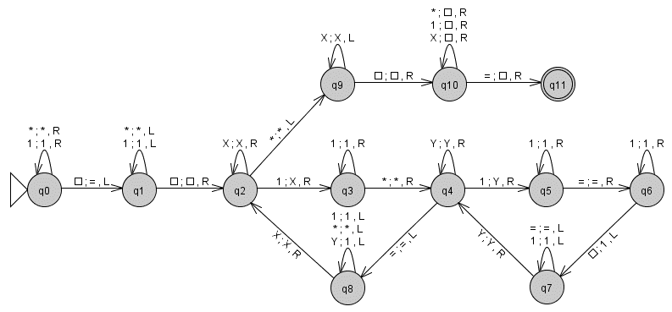
Description:
Step 1: Set ‘=’ symbol at the end of the input and start from the very first symbol
Step 2: Repeat the following until the current tape symbol becomes ‘*’
- Mark first ‘1’ by X and move forward until ‘*’ appears
- Copy all 1’s between ‘*’ and ‘=’ after the ‘=’ symbol
- Move backward until first ‘X’ appears
- Move one cell right.
Step 3: Scan forward, replace all symbols till ‘=’ by blank ‘B’. Stop

- TM to copy the given string over (0, 1)*
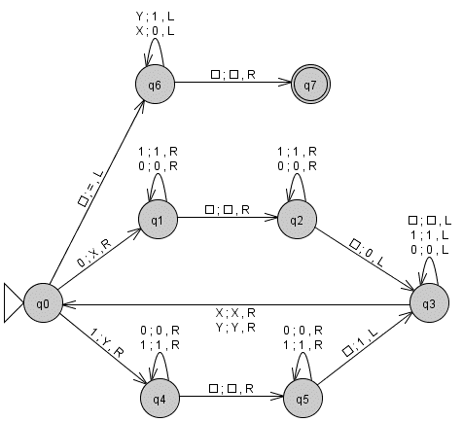
Description:
Step 1: Repeat the following until the current tape symbol becomes ‘B’
- Mark first ‘0’ by X or ‘1’ by Y, move forward until blank ‘B’ appears
Move forward until first blank appears and replace it by ‘0’ or ‘1’
- Move backward until first ‘X’ or ‘Y’ appears
- Move one cell right.
Step 2: Scan backward, replace all ‘X’ by 0 and ‘Y’ by 1 until blank appears. Stop
- TM to reverse the give string over (0, 1)*
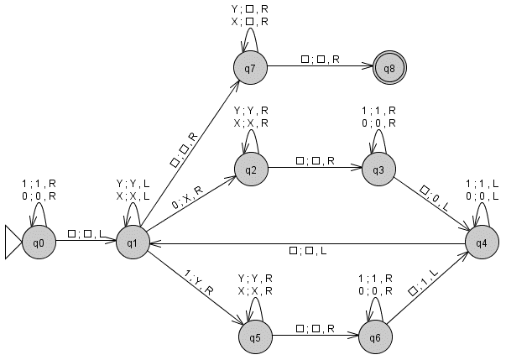
Description:
Step 1: Set the tape head to the last symbol of the string.
Step 2: Repeat the following until the current tape symbol becomes ‘B’
- Mark first ‘0’ by X or ‘1’ by Y, move forward until ‘B’ appears
- Move forward until first blank appears and replace it by ‘0’ or ‘1’
- Move backward until first blank ‘0’ or ‘1’ appears
Step 3: Scan forward, replace all symbols by ‘B’ until the first blank appears. Stop

- TM compute to compute $f\left(n\right)=n mod 2$
If n is unary:
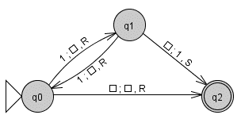
Description: Step 1: Scan forward, count and mark the ‘1’s by ‘B’ until the blank appears.
Step 2: If the count is odd, replace the blank by ‘1’.
Otherwise (even), replace the blank by blank.

If n binary:
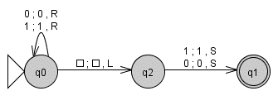
Description: Step 1: Scan forward as it is until the blank. Move one cell left.
Step 2: Replace 0 by 0 or 1 by 1. Stop

