CS6503 – THEORY OF COMPUTATION

UNIT III – PUSH DOWN AUTOMATA

- Important Definitions:
- Definition of PDA
PDA basically a Finite Automata with the auxiliary memory unit called stack. Formally, a PDA is a seven-tuple define by
M = (Q, Σ, δ, q₀, F, Г, Z₀)
Where Q: finite set of states
Σ: finite set of input alphabets
Г: finite set of stack symbols including Z₀
q₀: initial state of the PDA, q₀ ∈ Q
F: finite set of final states, F ⊆ Q
Z₀: Initial stack symbol
δ: transition function defined as Q x Σ x Г → Q x Г

- Compare FA and PDA
S. No. | Finite Automata (FA) | Push Down Automata (PDA)
1 | Five tuple automata | Seven tuple automata
2 | No auxiliary memory | Auxiliary memory in the form of Stack
3 | Deterministic by default | Non-deterministic by default
4 | Less power full than PDA in terms of language acceptance | More power full than NFA in terms of language acceptance
5 | Accepting only regular languages | Accepting both regular and context free languages
6 | Ex: $L=\left\{a^{n} \right| n≥0\}$ | Ex: $L=\{a^{n}b^{n} | n≥0\}$

- Instantaneous Description (ID) of PDA
ID of a PDA is a triple define as below used to describe the way of accepting the given string W by a PDA.
(q, w, s)
where q is the current state, w is the remaining input, s is the current stack content
Formally, let M = (Q, Σ, δ, q₀, F, Г, Z₀) be a PDA, then the ID of PDA is:
(p, aw, zα) ⊢ (q, w, Bα)

- Language Accepted by PDA
The language accepted by PDA is called Context-Free Language (CFL). There are two ways to describe the acceptance of language:
- Acceptance by final state
- Acceptance by empty stack
Let M = (Q, Σ, δ, q₀, F, Г, Z₀) be a PDA, w is the string ∈ Σ*
The language accepted by final state is defined as
$L=\{w|\left(q_{0},w,Z_{0}\right) ⊢_{}^{*} \left(q_{f},ε, α\right)\}$
Where $q_{f}$ ∈ F
α ∈ (Г, Σ)*
The language accepted by empty stack is defined as
$L=\{w|\left(q_{0},w,Z_{0}\right) ⊢_{}^{*} \left(q,ε, ɛ\right)\}$
Where q ∈ Q

Note 1:
The language accepted by final state is equivalent to language accepted by empty stack.

Note 2:
PDA by final state can be converted to PDA by empty stack as follows:
- Create a new state ‘q’ and add a transition from the final state $q_{f}$ of PDA to the new state q as below:
δ($q_{f}$, ɛ, Z) = (q, ɛ, ɛ)
- Mark all the states are non-final state (single circle)

- Types of PDA
Deterministic PDA (DPDA):
A PDA is deterministic, for the same input symbol and same stack symbol, there must be only one choice.
Formally, a PDA M = (Q, Σ, δ, q₀, F, Г, Z₀) is deterministic if
- δ(q, a, Z) has only one element
- δ(q, ɛ, Z) is not empty, then δ(q, a, Z) should be empty
If conditions (i) and (ii) are satisfied, then the PDA is deterministic

Non-deterministic PDA (NPDA):
A PDA is non-deterministic, for the input symbol and stack symbol, there is more than one choice.
Formally, non-determinism in a PDA can occur in the following cases:
- For the same stack symbol and same input symbol, there is more than one choice.
- For the same stack symbol and one input symbol is ‘ɛ’ and other input symbol is Σ.

Note:
The language accepted by Deterministic PDA is not equivalent to the language accepted by non-deterministic PDA.

- Important problems on PDA:

- PDA for the language $L=\{a^{n}b^{n} n≥0\}$
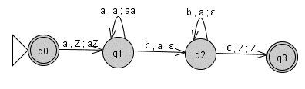
Description:
Step 1: Push all a’s onto the stack
Step 2: For every b in the tape, pop ‘a’ from the stack
Step 3: If the tape is empty and the stack is Z then accept the string.

Note: for the above language with n ≥ 1, mark q₀ is a non-final state (remove double circle).

- PDA for the language $L=\{a^{2n}b^{n} n≥0\}$
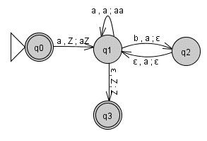
Description:
Step 1: Push all a’s onto the stack
Step 2: For every b in the tape, pop two a’s from the stack
Step 3: If the tape is empty and the stack is Z then accept the string.

- PDA for the language $L=\{a^{n}b^{2n} n≥0\}$
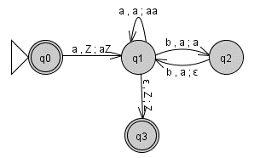
Description:
Step 1: Push all a’s onto the stack
Step 2: For every two b’s in the tape, pop ‘a’ from the stack
Step 3: If the tape is empty and the stack is Z then accept the string.

- PDA for the language $L=\left\{a^{n}b^{m}a^{2\left(m+n\right)}\right|m,n≥0\}$
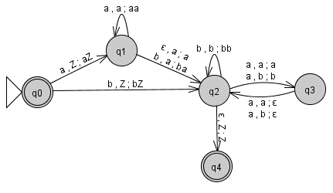
Description:
Step 1: Push all a’s and b’s onto the stack
Step 2: For every two a’s in the tape, pop ‘a’ or ‘b’ from the stack
Step 3: If the tape is empty and the stack is Z then accept the string.

- PDA for the language $L=\{a^{m}b^{n}c^{m}|m,n≥0\}$
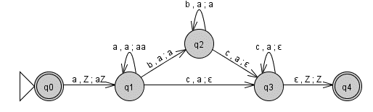
Description:
Step 1: Push all a’s onto the stack
Step 2: Don’t push b’s from tape onto the stack
Step 3: For every c’s in the tape, pop ‘a’ from the stack
Step 4: If the tape is empty and the stack is Z then accept the string.

- PDA for the language $L=\{x∈{\left(a,b\right)}^{*}|n_{a}\left(x\right)=n_{b}(x)\}$ or No. of a’s equal to No. of b’s.
Non-deterministic PDA:
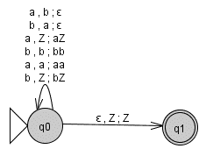
Deterministic PDA:
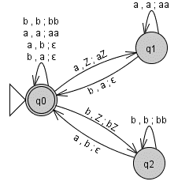
Description:
Step 1: Push only a’s onto the stack
Step 2: For every b in the tape, pop ‘a’ from the stack
Step 3: If the tape is empty and the stack is Z then accept the string.

- PDA for the language $L=\{wcw^{R}|w∈{(a,b)}^{*}\}$
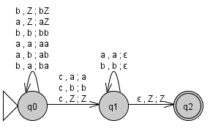
Description:
Step 1: Push a’s or b’s onto the stack until ‘c’ is appear.
Step 2: Don’s push c onto the stack
Step 3: For every ‘a’ in the tape, pop ‘a’ from the stack and
For every ‘b’ in the tape, pop ‘b’ from the stack
Step 4: If the tape is empty and the stack is Z then accept the string.
- Non-deterministic PDA for the language$L=\{ww^{R}|w∈{(a,b)}^{*}\}$ or
Even length Palindrome strings over (a, b)*.
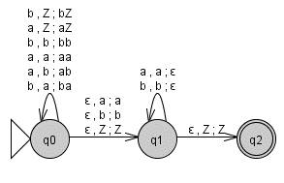
Step 1: Push a’s or b’s from the first half of the input onto the stack.
Step 2: Guess the first symbol of the W^{R} non-deterministically.
Step 3: For every ‘a’ in the tape, pop ‘a’ from the stack and
For every ‘b’ in the tape, pop ‘b’ from the stack
Step 4: If the tape is empty and the stack is Z then accept the string.

- Non-deterministic PDA for the language of palindrome strings (both odd & even length) over (a, b)*.
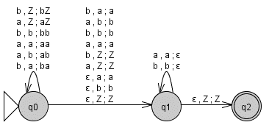
Step 1: Push a’s or b’s from the first half of the input onto the stack.
Step 2: Guess the middle symbol of the string non-deterministically.
Step 3: For every ‘a’ in the tape, pop ‘a’ from the stack and
For every ‘b’ in the tape, pop ‘b’ from the stack
Step 4: If the tape is empty and the stack is Z then accept the string.

- PDA for the language $L=\{x∈{\left(a,b\right)}^{*}|n_{a}\left(x\right)>n_{b}(x)\}$ or No. of a’s greater than No. of b’s.
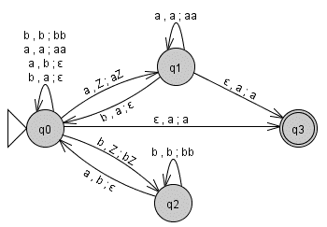

Description:
Step 1: Push only a’s onto the stack
Step 2: For every b in the tape, pop ‘a’ from the stack
Step 3: If the tape is empty and the stack is having ‘a’ then accept the string.

- PDA for the language $L=\left\{{(ab)}^{n}\right|n≥0\}$
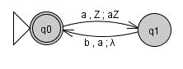
Description:
Step 1: Push ‘a’ onto the stack and pop ‘a’ from the stack for ‘b’ in the tape
Step 2: Repeat step 1 until the string is empty.
Step 3: If the tape is empty and the stack is Z then accept the string.

- PDA for the strings of balanced parenthesis
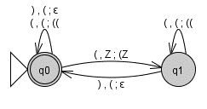
Description:
Step 1: Push only opening ‘(’s onto the stack
Step 2: For every ‘)’ in the tape, pop ‘(’ from the stack
Step 3: If the tape is empty and the stack is Z then accept the string.

- Equivalence of PDA and CFL:

- Conversion from PDA to CFL:
Theorem:
If L is a language for some PDA M, then prove that L is a context free language.
i.e., for every PDA M there is an equivalent CFG G accepting the language L.
Proof:
- Let PDA M defied by the seven tuples (Q, Σ, δ, q₀, F, Г, Z₀).
- Assume if L is a CFL then there must be a CFG G corresponding to L and it is defined by the four tuples (N,T,P,S)
- From the PDA M above, the CFG G can be constructed as follows:
N = {S, [p A q]} where p, q∈Q; A∈N
T = Σ
The productions P for the start symbol S and all the non-terminals A can be defined by the following rules:
- For the start symbol S, the production is
S → [q₀ Z₀ q] where q∈Q
- For any transition function is in the form δ(p, a, A)=(q, ɛ), the production is
[p A q] → a Where p, q ∈ Q; A ∈ Г ; a ∈T
- For any transition function is in the form δ(p, a, A)=(q, B₁ B₂ B₃…B_{n}), the production is
[p A q_{n+1}] → a [q B₁ q₁][q₁ B₂ q₂]…..[q_{n} B_{n} q_{n+1}]
Where p, q, q_{1,} q₂, …, q_{n+1} ∈ Q;
A, B₁, B₂, …, B_{n} ∈ Г ; a ∈T

Conclusion:
Hence, from the above procedure it is shown that there is an equivalent Context-Free Grammar G for every Push Down Automata M such that L(G) = L(M).

- Conversion from CFL to PDA:
Theorem:
Let L be a context free language. Then prove that there exists a PDA M such that L=L(M).
Proof:
- If L is a CFL then there must be a CFG G in GNF form corresponding to L. Assume G is defined by the four tuples (N,T,P,S)
- From the CFG G above, the PDA M can be constructed as follows:
Assume PDA M = (Q, Σ, δ, q₀, F, Г, Z₀)
Where, Q=$\{q_{0},q_{1},q_{2}\}$; Σ=T; Initial state=q₀; F=q₂; Г={Σ, Z₀, N}
Where, δ can be defined by the following rules:
- Place the start symbol S on the stack
δ($q_{0}$, ɛ, Z₀) = ($q_{1}$, SZ₀)
- For each non-terminal A∈N where A→α,
δ($q_{1}$, ɛ, A) = ($q_{1}$, α)
- For each terminal a∈T,
δ($q_{1}$, a, a) = ($q_{1}$, ɛ)
- To reach to the final state,
δ($q_{1}$, ɛ, Z₀) = ($q_{2}$, Z₀)
Conclusion:
Hence, from the above procedure it is shown that there is an equivalent Push Down Automata M for every Context-Free Grammar G such that L(M) = L(G).

