CS6503 - THEORY OF COMPUTATION
16 mark questions
Subject Code /Title: CS6503 Theory of Computation Year / Sem: III / V
UNIT-I AUTOMATA

- a) If L is accepted by an NFA with ε-transition then show that L is accepted by an NFA without ε-transition.
b) Construct a DFA equivalent to the NFA. M=({p,q,r},{0,1}, δ,p,{q,s})
Where δis defined in the following table.

δ | 0 | 1
p | {q,s} | {q}
q | {r} | {q,r}
r | {s} | {p}
s | - | {p}
- a)Show that the set L={an bn/n>=1} is not a regular.
b)Construct a DFA equivalent to the NFA given below:
 | 0 | 1
p | {p,q} | P
q | r | R
r | s | -
s | s | S
- a)Check whether the language L=(0n 1n /n>=1) is regular or not? Justify your answer.
b) Let L be a set accepted by a NFA then show that there exists a DFA that accepts L.
- Define NFA with ε-transition. Prove that if L is accepted by an NFA with ε- transition then L is also accepted by a NFA without ε-transition.
- a) Construct a NDFA accepting all string in {a,b}+ with either two consecutive a’s or two consecutive b’s.
b) Give the DFA accepting the following language: set of all strings beginning with a 1 that when interpreted as a binary integer is a multiple of 5.
- Draw the NFA to accept the following languages.
  - Set of Strings over alphabet {0,1,…….9} such that the final digit has appeared before.
  - Set of strings of 0’s and 1’s such that there are two 0’s separated by a number of positions that is a multiple of 4.
- a) Let L be a set accepted by an NFA. Then prove that there exists a deterministic finite automaton that accepts L.Is the converse true? Justify your answer.
b) Construct DFA equivalent to the NFA given below:
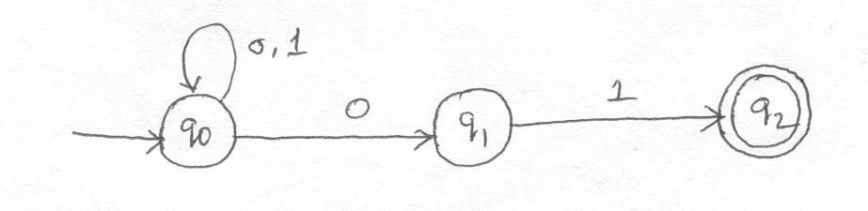

- a) Prove that a language L is accepted by some ε–NFA if and only if L is accepted by some DFA.
b) Consider the following ε–NFA. Compute the ε–closure of each state and find it’s equivalent DFA.

 | ε | A | b | C
p | {q} | {p} | Ф | Ф
q | {r} | ф | {q} | Ф
*r | Ф | ф | ф | {r}

- a) Prove that a language L is accepted by some DFA if L is accepted by some NFA.
b) Convert the following NFA to it’s equivalent DFA

 | 0 | 1
p | {p,q} | {p}
q | {r} | {r}
r | {s} | ф
*s | {s} | {s}

10. a) Explain the construction of NFA with ε transition from any given regular expression.
b) Let A=(Q,∑, δ, q0 ,{qf ) be a DFA and suppose that for all a in ∑ we have δ(q0, a)= δ(qf ,a). Show that if x is a non empty string in L(A),then for all k>0,xk is also in L(A).
11. Construct an NFA equivalent to (0+1)*(00+11)
12. a) Construct a Regular expression corresponding to the state diagram given in the following figure.
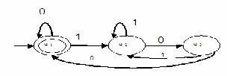
b) Show that the set E={0i 1i |i>=1} is not Regular.
13. a) Construct an NFA equivalent to the regular expression (0+1)*(00+11)(0+1)*.
b) Obtain the regular expression that denotes the language accepted by the following DFA.

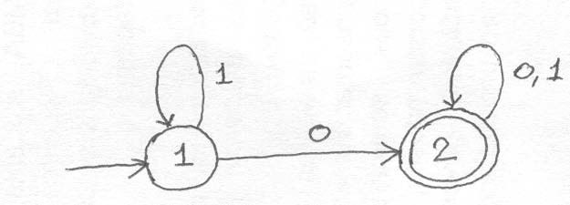

14. a) Construct an NFA equivalent to the regular expression ((0+1)(0+1)(0+1))* b)Construct an NFA equivalent to 10+(0+11)0*1
15. a) Obtain the regular expression denoting the language accepted by the following DFA
b) Obtain the regular expression denoting the language accepted by the following DFA by using the formula Rij k

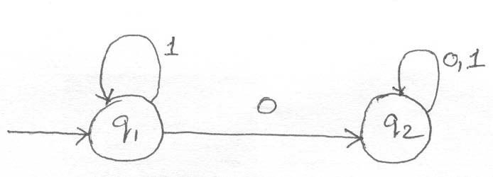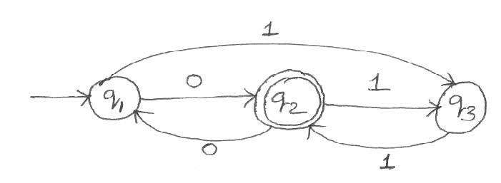

- a)Show that every set accepted by a DFA is denoted by a regular Expression
b) Construct an NFA equivalent to the following regular expression01*+1.
- a) Define a Regular set using pumping lemma show that the language L={0i2 / i is an integer, i>=1} is not regular
b) Construct an NFA equivalent to the regular expression 10+(0+11)0*1
- a) Show that the set L={On2/n is an integer, n>=1} is not regular.
b)Construct an NFA equivalent to the following regular expression ((10)+(0+1) * 01.

19. a) Prove that if L=L(A) for some DFA A, then there is a regular expression R such that L=L(R).
b) Show that the language {0p,p is prime} is not regular.
20. a) Find whether the following languages are regular or not.
(i)L={w ε{a,b}|w=wR}.
(ii) L={0n 1m 2n+m,n,m>=1} (iii) L={1k|k=n2,n>=1} . (4)
(iv) L1/L2={x | for some y εL2,xy εL1},where L1 and L2 are any two languages and L1/L2 is the quotient of L1 and L2.
b) Find the regular expression for the set of all strings denoted by R213 from the deterministic finite automata given below:
ww..rree
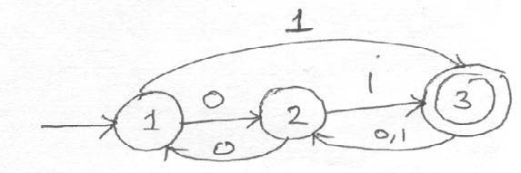

UNIT-II
GRAMMARS

- a) Let G be a CFG and let a=>w in G. Then show that there is a leftmost derivation of w.
b) Let G=(V,T,P,S) be a Context free Grammar then prove that if S=> αthen there is a derivation tree in G with yield α.
- Let G be a grammar s->OB/1A, A->O/OS/1AA, B->1/1S/OBB. For the string 00110101 find its leftmost derivation and derivation tree.
3. a) If G is the grammar S->Sbs/a, Show that G is ambiguous.
b) Give a detailed description of ambiguity in Context free grammar
- a) Show that E->E+E/E*E/(E)/id is ambiguous. (6) b)Construct a Context free grammar G which accepts N(M), where M=({q0, q1},{a,b},
{z0,z},δ,q0,z0,Φ) and where δis given by
δ(q0,b,z0)={(q0,zz0)}
δ(q0, ε,z0)={(q0, ε)}
δ(q0,b,z)={(q0,zz)}
δ(q0,a,z)={(q1,z)}
δ(q1,b,z)={(q1, ε)} δ(q1,a,z0)={(q0,z0)}

b) If L is Context free language then prove that there exists PDA M such that L=N(M).
5. a) Construct a equivalent grammar G in CNF for the grammar G1 where G1
=({S,A,B},{a,b},{S->bA/aB,A->bAA/aS/a, B->aBB/bS/b},S)
b)Find the left most and right most derivation
corresponding to the tree.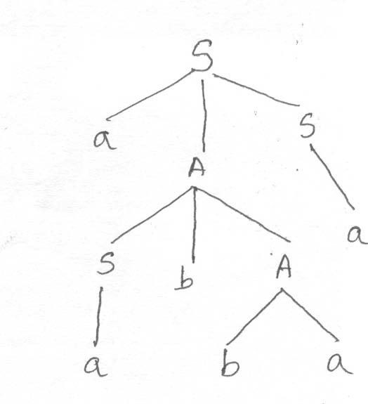
- a) Find the language generated by a grammar G=({S},{a,b},{S->aSb, S->ab},S) (4)
- Given G=({S,A},{a,b},P,S) where P={S->AaS|S|SS,A->SbA|ba}
S-Start symbol. Find the left most and right most derivation of the string w=aabbaaa. Also construct the derivation tree for the string w.
- Define a PDA. Give an Example for a language accepted by PDA by empty stack.
- G denotes the context-free grammar defined by the following rules. ` S->ASB/ab/SS A->aA/A ,B->bB/A
  - )Give a left most derivation of aaabb in G. Draw the associated parse tree.
- Give right most derivation of aaabb and draw the associated parse tree.
- Show that G is ambiguous. Explain with steps.
(iv) Construct an unambiguous grammar equivalent to G. Explain.
- a)Find a grammar in Chomsky Normal form equivalent to S->aAD;A->aB/bAB;
B->b, D->d.
b) Convert to Greibach Normal Form the grammar G=({A1,A2, A3},{a,b},P,A1 ) where P consists of the following. A1 ->A2 A3, A2 ->A3 A1 /b, A3 ->A1 A2 /a.
9. a) Show that the language {0n1n22/n>=1} is not a Context free language.
b) Convert the grammar S->AB, A->BS/b, B->SA/a into Greibach NormalForm.
10. a) Construct a equivalent grammar G in CNF for the grammar G1 where
G1=({S,A,B},{a,b},{S->bA/aB,A->bAA/aS/a, B->aBB/bS/b},S)
b) Obtain the Chomsky Normal Form equivalent to the grammarS->bA/aB,
A->bAA/aS/a, B->aBB/bS/b.
11. a) Begin with the grammar S->0A0/1B1/BBA->CB->S/AC->S/ ε and simplify using
the safe order Eliminate ε-Productions Eliminate unit production Eliminate
useless symbols Put the (resultant) grammar in Chomsky Normal Form
b) Let G=(V,T,P,S) be a CFG. Show that if S=α, then there is a derivation tree in a grammar G with
yield α.
12. a) Let G be the grammar S->aS/aSbS/ ε. Prove that L(G)={x/each prefix of x has atleast as many a's
as b's}
b) Explain the construction of an equivalent grammar in CNF for the grammar G=({S,A,B}{a,b},P,S) where P={S->bA|aB, A->bAA|aS|a, B->aBB|bS|b}
13.a)Find a Context free grammar with no useless symbol equivalent to S->AB/CA, B->BC/ABA->a, C->aB/b.
b)Show that any CFL without εcan be generated by an equivalent grammar in Chomsky Normal Form.
14. a)Convert the following CFG to CNF S->ASA|aB A->B|S B->b| ε
b)Explain about Greibach Normal Form.

UNIT-III
PUSHDOWN AUTOMATA
- Construct a PDA accepting {anbman/m,n>=1} by empty stack. Also construct the corresponding context-free grammar accepting the same set.
- a) Prove that L is L(M2 ) for some PDA M2 if and only if L is N(M1) for some PDA M1.
b)Define deterministic Push Down Automata DPDA. Is it true that DPDA and PDA are equivalent in the sense of language acceptance is concern? Justify Your answer.
3. a) Construct the grammar for the following PDA.
M=({q0, q1},{0,1},{X,z0},δ,q0,Z0,Φ) and where δ is given by
δ(q0,0,z0)={(q0,XZ0)}, δ(q0,0,X)={(q0,XX)},δ(q0,1,X)={(q1, ε)},
δ(q1,1,X)={(q1, ε)},δ(q1, ε,X)={(q1, ε)}, δ(q1, ε, Z0 )={(q1, ε)}. (12)
b) Prove that if L is N(M1) for some PDA M1 then L is L(M2 ) for some PDA M2.
4. a) Construct a PDA that recognizes the language {ai bj ck| i,j,k>0 and i=j or i=k}.
  - Discuss about PDA acceptance
    - From empty Stack to final state.
    - From Final state to Empty Stack.
5. a)Is L={an bn cn /n>=1} a context free language? Justify Your answer.
b)Prove that for every context free language L without εthere exists an equivalent grammar in Greibach Normal Form.
4. State and Prove pumping lemma for Context free languages.
5. a) State Pumping Lemma for context free language. Show that (0n 1n 2n/n>=1} is not a Context free
language.
b) State Pumping lemma for context free language σshow that language {ai bj ci dj/i>=1, and j>=1} is not context-free.

UNIT - IV
TURING MACHINES

1. a) Design a Turing Machine M to implement the function “multiplication” using the subroutine ‘copy’.
b) Explain how a Turing Machine with the multiple tracks of the tape can be used to determine the given number is prime or not.
2. a) Design a Turing Machine to compute f(m+n)=m+n, V m,n>=0 and simulate their action on the input 0100.
b) Describe the following Turing machine and their working. Are they more powerful than the Basic
Turing Machine? Multi-tape Turing Machine Multi-Dimensional Turing Machine
3. a) Define Turing machine for computing f(m,n)=m-n ( proper subtraction).
b) Explain how the multiple tracks in a Turing Machine can be used for testing given positive integer
is a prime or not.
4. Explain the programming techniques for Turing Machine construction.
5. State and describe the halting problem of Turing Machine.
6. Describe the Chomsky Hierarchy of Languages.

UNIT - V
UNSOLVABLE PROBLEMS AND COMPUTABLE FUNCTIONS
- a)Show that union of recursive languages is recursive
b)Define the language Ld and show that Ld is not recursively enumerable language.
- a) Define Universal language Lu.Show that Lu is recursively enumerable but not recursive.
b)Show that Ln is recursively enumerable.
- a)Define Ld and show that Ld is not recursively enumerable.
b)Whether the problem of determining given recursively enumerable language is empty or not? Is decidable? Justify your answer.
4. Define the language Lu. Check whether Lu is recursively enumerable? or Lu is recursive? Justify your
answer.
5. a)Show that the language Ld is neither recursive nor recursively enumerable.
b)Describe how a Turing Machine can be encoded with 0 and 1 and give an example.
6. a)Show that any non trivial property J of the recursively enumerable languages is undecidable.
b)Show that if L and L are recursively enumerable then L and L recursive.
- Define the universal language and show that it is recursively enumerable but not recursive.
- Prove that the universal language Lu is recursively enumerable.
- State and Prove Rice’s Theorem for recursive index sets.
10. a)Show that the following language is not decidable. L={<M>| M is a TM that accepts the string aaab}.
b)Discuss the properties of Recursive and Recursive enumerable languages.
11. a)Define Post correspondence problem with an example.
b)Prove that the function f(n)=2n does not grow at a polynomial rate, in other words, it does not satisfy f(n)=O(np ) for any finite exponent p.
12.a) Define the language Ld. Show that Ld is neither recursive nor recursively enumerable.
- Show that if a language L and its complement L are both recursively enumerable then L is recursive.
13. a)What are the features of a Universal Turing Machine?
  - Show that “If a language L and its compliment L are both recursively enumerable, then both languages are recursive”.
  - Show that halting problem of Turing Machine is undecidable.
14. a) Does PCP with two lists x=(b,bab³,ba) and y=(b³,ba,a) have a solution? b)Show that the characteristic function of the set of
all even numbers is recursive.
15. a)Show that it is undecidable for arbitrary CFG’s G1 and G2 whether L(G1)∩L(G2)Is a CFL.
b)Show that “finding whether the given CFG is ambiguous or not” is undecidable by reduction technique.
16.Find whether the following languages are recursive or recursively enumerable.
- Union of two recursive languages.
- Union of two recursively enumerable languages.
- L if L and complement of L are recursively enumerable.
- Lu
17. Explain the Post’s Correspondence Problem with an example
18. (i)Union of two recursive languages.
(ii)Union of two recursively enumerable languages
(iii)L if L and complement of L are recursively enumerable
19. Discuss about tractable and Intractable problems.

